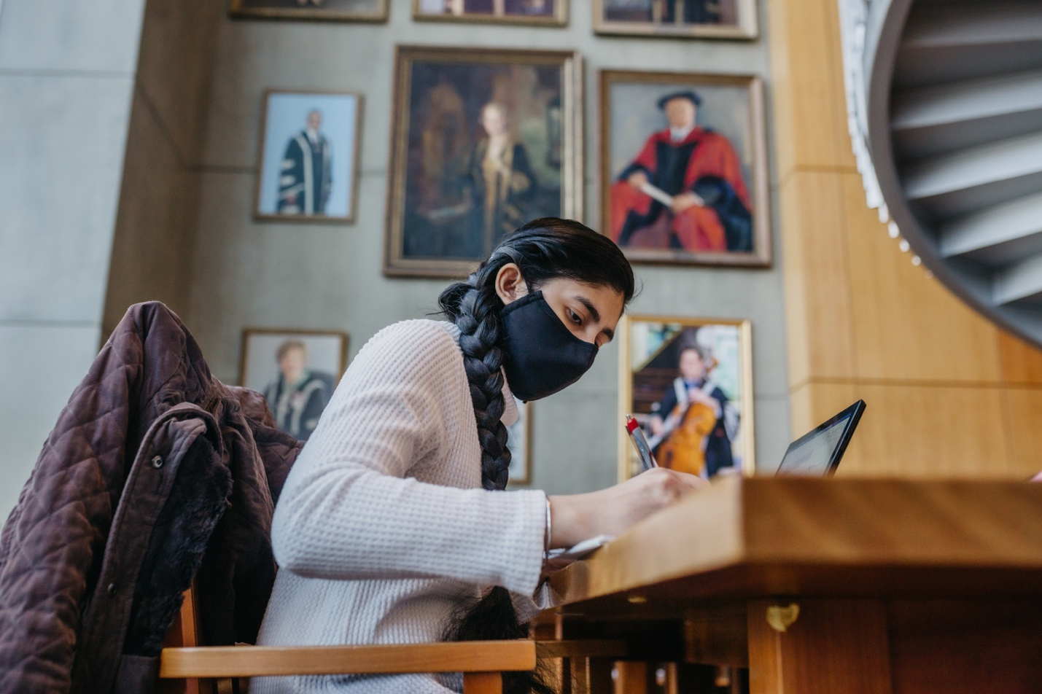

UBC Library

2021/22

Senate Report

Table of Contents

Message from the University Librarian – Pages 3-4

Section 1
Advance Research, Learning and Scholarship – Pages 5-7

Fundraising for the future – Page 8

Section 2
Engage with Communities – Pages 9-11

Section 3
Create and Deliver Responsive Collections – Pages 12-14

UBC Library at a glance – Page 15

Statement of revenue & expenditures – Page 16

Section 4
Inspire with Innovative Spaces and Services – Pages 17-19

Section 5
Steward the Organization – Pages 20-21

UBC Okanagan Library Highlights – Page 22

Acknowledgements – Page 23

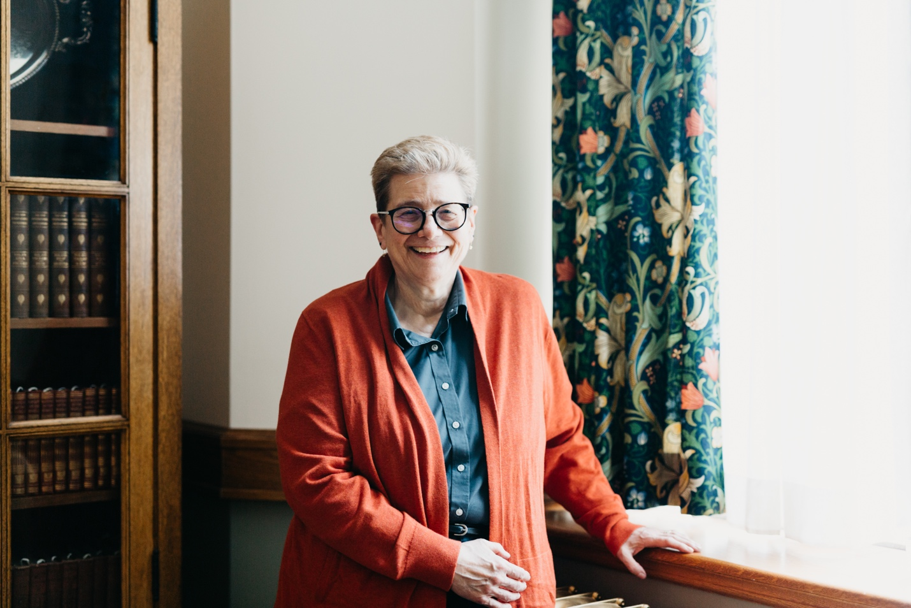

Message from the University Librarian

2021/2022 has been a year of transition, one that has given the library a unique opportunity to revaluate and recalibrate. We transitioned back to fully in-person operations on campus in September 2021, kicking off a year of hybrid teaching, learning and work. We adapted to this transition by phasing out some of the services developed in response to COVID-19 while maintaining others to meet the ever-changing needs of our users.

The library underwent an external review in March 2022, which culminated in a report outlining eight recommendations. Overall, the report described UBC Library as a “strong research library, greatly appreciated by its academic and research communities” and that “the organization is on the right path” to addressing our many challenges.

The external review process gave us an opportunity to surface the progress made on the implementation of our Strategic Framework; we have re-imagined the committee structure, transitioning to teams, working groups and communities of practice with the key goal of creating groups of people with the appropriate knowledge and skills to work together across the system.

The process also allowed us to share our efforts alongside the University’s urgent priorities in Equity, Diversity and Inclusion outlined in the Inclusion Action Plan (IAP) and the Indigenous Strategic Plan (ISP). We have thrown ourselves into learning and action, and work is underway to change our practices for recruitment, hiring, and retention.

We are engaged with the University’s anti-racism and anti-Asian hate initiatives and are actively working in alignment with campus ISP and Inclusion Action Plan (IAP) groups.

We were also able to highlight the library’s contributions to the University’s Climate Action Plan like the Library #ClimateAction Team’s Air Travel Decision Tree tool that supports library faculty and staff in decision-making around business travel.

In 2021, we implemented OpenAthens, an access management service which provides a more reliable and streamlined experience for library users. It has also allowed us access to fulsome usage data, which will enable us to reallocate resources and help inform decision-making around our collections budget.

Finally, it has been thrilling to add a first edition of William Shakespeare’s Comedies, Histories and Tragedies (or First Folio) to our collection thanks to the generosity of a consortium of donors, and especially gratifying to make it available for viewing to thousands of people through an exhibit at the Vancouver Art Gallery.

The impressive outcomes outlined in this report are a reflection of the dedication and resilience of UBC Library faculty and staff as we navigate constant and transformational change. I am so proud of what we have accomplished together and I look forward to what’s to come.

– Dr. Susan E. Parker

Section 1

Advance Research, Learning and Scholarship

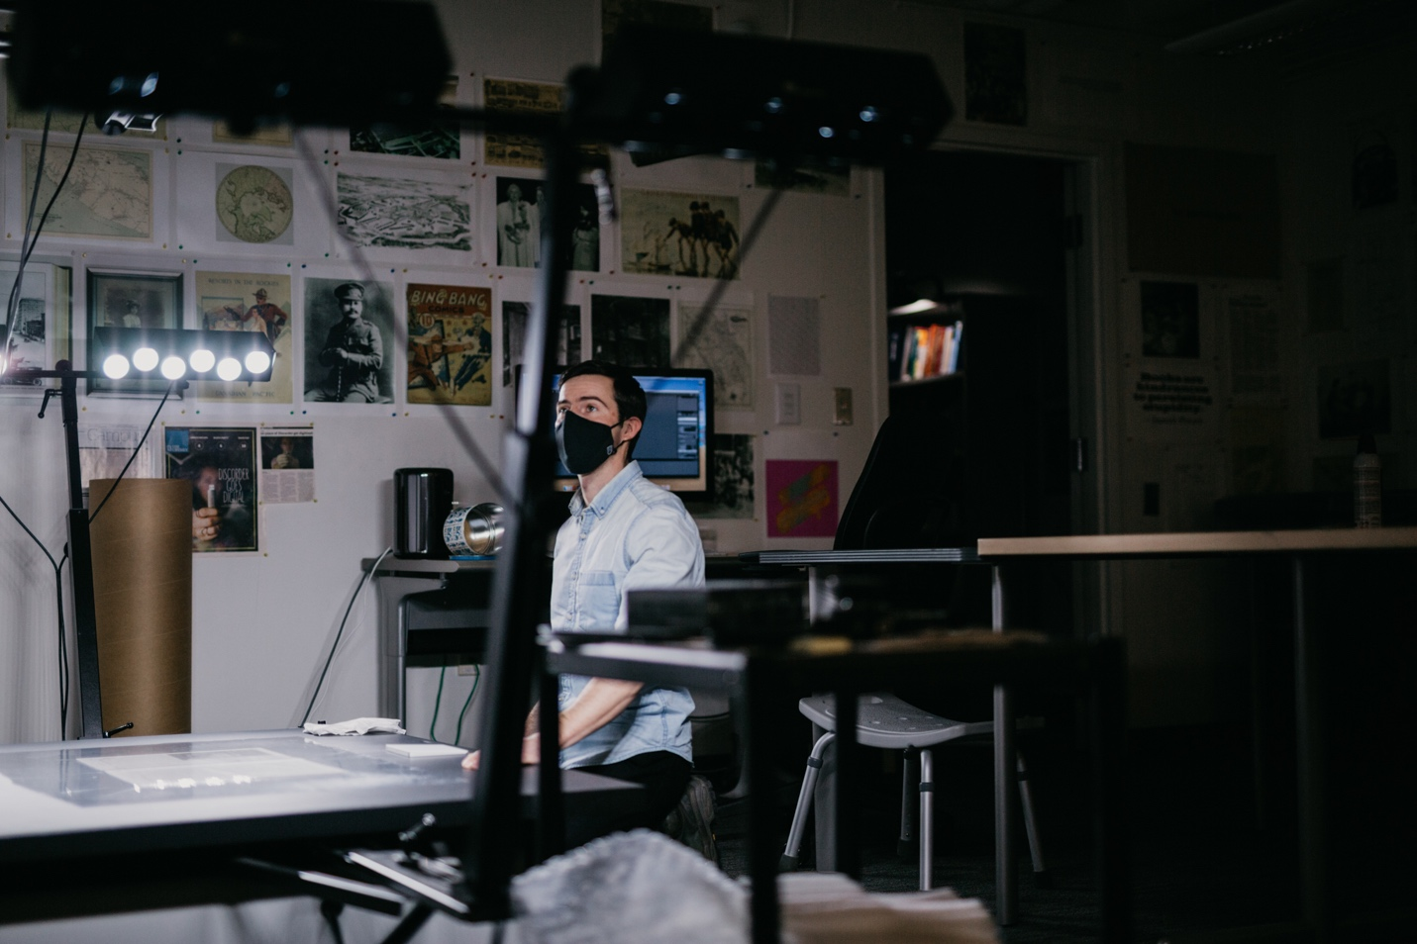

Articles: Advance Research, Learning and Scholarship

- Building web archives to document pandemic response in British Columbia
- Making valuable housing data available to UBC researchers
- Remote reference and virtual teaching
- Helping researchers build scholarly profiles
- UBC Library Open Publishing Program
- Curating open educational resources for UBC instructors
- Expanding geospatial search through Geodisy integration
- Supporting data visualization
- UBC Library joins Dryad membership

Building web archives to document pandemic response in British Columbia
Digital Initiatives creates web archives to preserve materials relating to the COVID-19 pandemic response in British Columbia for future research. These open collections document different facets of the pandemic response by capturing digital materials such as media releases, local news articles, UBC communications, BC provincial government websites and more.

Making valuable housing data available to UBC researchers
UBC researchers gain access to the Data Advice and Inventory Extracts provided by BC Assessment, which include value assessments for just over two million properties in British Columbia. By stewarding access to this highly valuable licensed data set, and simplifying the distribution process, the library creates new opportunities for community-university research projects.

Remote reference and virtual teaching
UBC librarians and library staff find new ways to collaborate with faculty and students by offering remote reference through online video conferencing platforms like Zoom. Librarians at David Lam Library introduce flexible timing and new virtual presentations that adapt library orientation sessions for remote classes.

Helping researchers build scholarly profiles
Scholarly Communications and Copyright launches a new webinar series that focuses on the open publishing process and practices in the humanities, social sciences and sciences. Faculty, graduate and post-doctoral students gain the opportunity to learn more about developing their academic profiles.

UBC Library Open Publishing Program
The library launches an open access journal and text service to help UBC faculty, researchers, instructors, students and staff develop open access publications for scholarship and instruction. This free service advances open scholarship by providing the supports needed to make UBC information resources openly available.

Curating open educational resources for UBC instructors
Instructors at UBC and beyond can search through a new curated database full of openly accessible teaching and learning materials. Developed in partnership with the UBC Centre for Teaching, Learning and Technology, UBC Okanagan Library and UBC Library, the UBC OER Collection showcases open educational resources in a searchable interface to support both UBC faculty and the general community in incorporating open educational resources and practices into their curriculums.

Expanding geospatial search through Geodisy integration
The Research Commons releases a major update to the open-source data discovery tool Geodisy. Through an integration with the Federated Research Data Repository Discovery Portal, the collection available for geospatial search expands to include more than 86,000 records from over 70 Canadian research data repositories.

Supporting data visualization
The Research Commons partners with the UBC Future Waters Research Excellence Cluster to develop a model to visualize research outputs. Using open source tool Scholia, research groups can download a free version of the workflow to create graphical representations of their publication data using pre-existing records in sites like Wikidata.

UBC Library joins Dryad membership
UBC Library becomes the first Canadian institution to join Dryad. This non-profit membership organization brings together a thriving global community of universities, research institutions and academic libraries all working together to promote data publishing, curation, and preservation. With more than 600 UBC-authored datasets already available in Dryad, institutional membership provides UBC-affiliated researchers with access through their Campus-Wide Login (CWL) and unlimited dataset submissions at no cost.

Fundraising for the Future

Donor support enables the library to enhance student learning, helps researchers find answers and advances knowledge to its fullest potential. Donations can help build spaces, connect ideas, and allow the library to provide a margin of excellence beyond what public dollars provide.

How donors connect with us

37% – Web
26% – Mail
21% – Personal solicitations
16% – Phone

Total funds raised*

$8.4 Million

*Numbers reflect the fundraising efforts for UBC Library’s Vancouver campus only

Number of gifts

558

Funds raised

$7.16M – Outright donations
$1.1M – Gifts-in-kind
$164K – Realized bequest
$31K – Pledges

Section 2
Engage with Communities

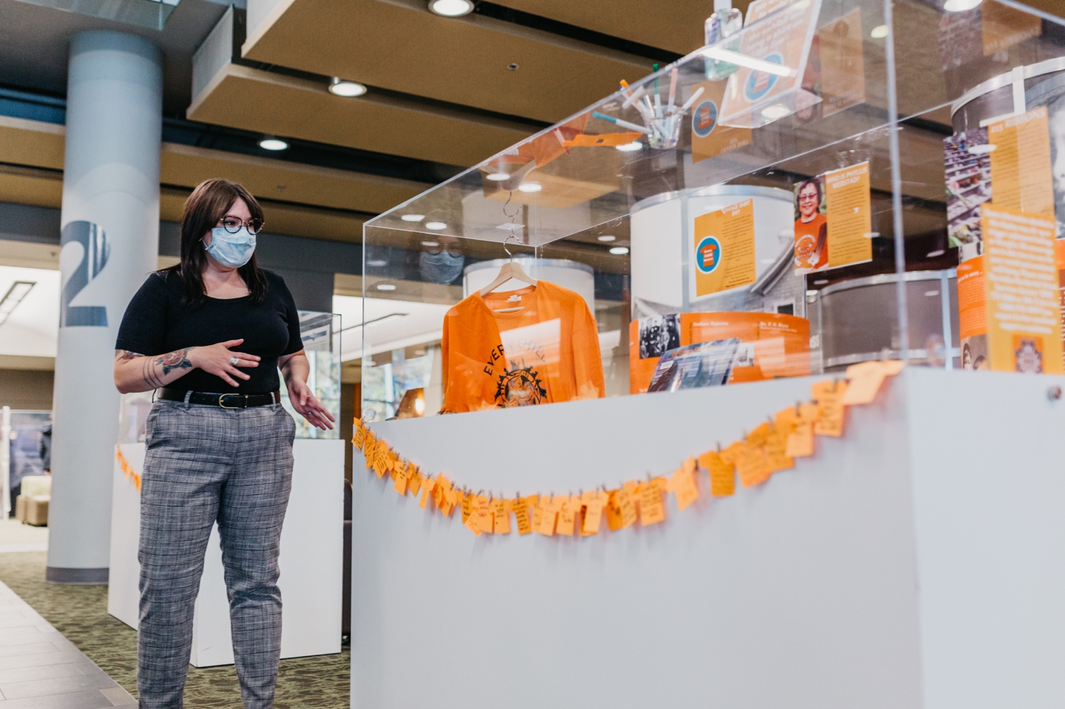

Articles: Engage with Communities

- Generations Lost: Healing the Legacy of Residential Schools
- I Know We’ll Meet Again: Correspondence and the Forced Dispersal of Japanese Canadians
- Providing digitization support to unique collections
- Celebrate Student Research: Games in Asia
- Surfacing data about marginalized and underrepresented populations
- Library #ClimateAction Team film screenings
- UBC Library supports Forest(Reads) series and Vancouver Black Library book drive

Generations Lost: Healing the Legacy of Residential Schools
As part of the Generations Lost exhibits, presented in partnership by the Faculty of Education and UBC Library at the Irving K. Barber Learning Centre, Xwi7xwa Library curates several display cases of special collections material relating to Residential Schools in Canada. The cases also include unique items like the cedar shavings collected from the Reconciliation Pole carved by 7idansuu (Edenshaw) James Hart, Haida Hereditary Chief, as well as medicinal plants like sage and cedar bundles.

I Know We’ll Meet Again: Correspondence and the Forced Dispersal of Japanese Canadians
UBC Library and the Asian Canadian and Asian Migration Studies program in the Faculty of Arts present an online public panel event inspired by the Joan Gillis fonds, a remarkable collection of letters that recount the lives of a group of Japanese Canadian teenagers after their forced dispersal from the coastal regions of British Columbia in 1942. Nearly 200 people tune in to hear the panel of artists, scholars, and archivists from the Japanese Canadian community and learn about the library’s new digital exhibit, featuring select letters from the fonds.

Providing digitization support to unique collections
A new partnership between the BC Electronic Library Network (BC ELN) and the Irving K. Barber Learning Centre offers vital support to prospective BC History Digitization Program (BCHDP) grant applicants seeking to bring their unique collections online. The BC ELN- BCHDP Support Service is a three-year pilot program that provides small GLAM (Galleries, Libraries, Archives, and Museums) sector organizations with a range of support services to help them prepare and apply for BCHDP grant funding.

Celebrate Student Research: Games in Asia
The Asian Library and the Department of Asian Studies present a joint moderated session to discuss games in Asia, as part of Celebrate Learning Week. From traditional games like marbles in India and board games like the Japanese Edo-period Sugoroky, to the sociocultural impact of digital gaming and Chinese e-sports fandom, the session covers a wide range of topics.

Surfacing data about marginalized and underrepresented populations
The library offers a series of workshops on finding data about marginalized and underrepresented populations. Indigenous Peoples, racialized groups and people who identify as LGBTQ+ are often underrepresented or hidden in the datasets that people rely on for research and planning. Data about mental health, substance abuse, and homelessness can be difficult to find, particularly for marginalized populations. The Finding the Data workshop series helps identify potential data sources and discuss the historical and social context that can make the data harder to find.

Library #ClimateAction Team film screenings
The Library #ClimateAction Team (L#CAT) and the EDI Recruitment & Retention working group offer free, online screenings of three films related to climate change, social justice, and the land. Screenings are funded by a UBC Workplace Sustainability grant.

UBC Library supports Forest(Reads) series and Vancouver Black Library book drive
UBC Library partners with Forest(Reads), the Faculty of Forestry’s virtual book club on justice, equity, diversity and inclusion. This year’s series focuses on understanding Black experiences within the environmental field through the writings of author and cultural geographer Dr. Carolyn Finney. UBC Library, UBC Okanagan Library, the UBC Learning Exchange and Iron Dog Books collaborate to launch a book drive to collect a variety of Black literature to support the Vancouver Black Library (VBL). Spearheaded by UBC student Maya Preyshon, the VBL is a space to sign out books for free and a “study space, a chill space, and a safe space” catering to the needs of the Black community in Vancouver.

Section 3
Create and Deliver Responsive Collections

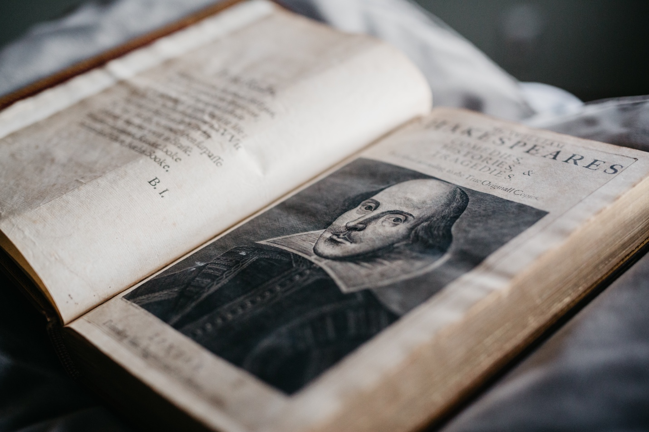

Articles: Create and Deliver Responsive Collections

- William Shakespeare’s Comedies Histories and Tragedies
- The Phil Lind Klondike Gold Rush Collection
- UBC Department of Athletics & Recreation fonds
- Afghan Serials Collection and Afghan Central Press digital archive
- Adding to UBC’s Queer Collection
- The Province newspaper digital archives

William Shakespeare’s Comedies Histories and Tragedies
The library acquires a first edition of William Shakespeare’s Comedies, Histories and Tragedies. Published in 1623, seven years after Shakespeare’s death, the First Folio includes 36 of Shakespeare’s 38 known plays. The texts, edited by Shakespeare’s close friends, fellow writers and actors, are considered the most authoritative of all early printings. The First Folio, formerly owned by a private collector in the USA, is purchased through Christie’s New York with funding provided by a consortium of donors from across North America and with the generous support of the Department of Canadian Heritage.

The First Folio is made available for public viewing alongside three subsequent seventeenth-century Folio editions of Shakespeare’s plays in For All Time: The Shakespeare First Folio, an exhibit presented in partnership with the Vancouver Art Gallery. Curated by Gregory Mackie, Associate Professor of English and Norman Colbeck Curator and Katherine Kalsbeek, Head, UBC Library Rare Books and Special Collections, the exhibit marks the first time all four Folios have been displayed in Vancouver. The exhibit sees over 45,000 visitors between January and April 2022.

The Phil Lind Klondike Gold Rush Collection
The library receives an unparalleled rare book and archival collection, dating from the Klondike Gold Rush (1894-1904), from UBC alumnus and Canadian telecommunications icon Philip B. Lind, CM. The collection includes books, maps, letters and photos collected by Lind, whose grandfather, Johnny Lind, was a trailblazer who carved out success as a prospector, arriving in the Yukon two years before the big Klondike strike in 1896 that ignited the gold rush.

A $2 million gift supports the collection at the library and the Department of Canadian Heritage’s Canadian Cultural Property Export Review Board designates
the collection as a cultural property of outstanding significance.

UBC Department of Athletics & Recreation fonds
UBC Archives receives an extensive collection of materials from UBC’s Department of Athletics and Recreation, totalling nearly 8,000 photographs along with textual records like scrapbooks, posters, programs, team rosters, scoresheets, training schedules and other administrative documents from the athletics side of the department. The records span a century from approximately 1915 to 2015, and reflect the university’s rich sporting history.

Afghan Serials Collection and Afghan Central Press digital archive
Faculty, staff and students gain access to the Afghan Serials Collection (DA-ASC) Partisan Publications from the Wahdat Library as well as the Afghan Central Press digital archive, addressing in part the needs of students and faculty conducting research in Afghan Studies. The Afghan Serials Collection spans 46 newspapers and journals from the 1970s to 1990s and includes over 2,500 articles published in Persian, Pushto, Arabic, Urdu, and English.

Adding to UBC’s Queer Collection
Thanks to Giving Day 2021 donations, the library purchases three rare items that are added to UBC’s Queer Collection at Rare Books and Special Collections: Messes Noires: Lord Lyllian (1905) by Jacques d’Adelsward Fersen (1880-1923), Ercole Tomei (1900) by Guido Hermann Eckardt (1873-1951), and The Classification of Crimes: being a seventeenth chapter of A History of Penal Methods (1904) by George Ives (1867- 1950). The items will be preserved for future students and scholars as part of this essential collection.

The Province newspaper digital archives
The library acquires access to the digital archives of The Province newspaper from 1894 to 2010. As one of Vancouver’s two major daily newspapers, The Province digital archives is a valuable new resource for scholarship and teaching, further expanding UBC Library’s already extensive collection of current and historical British Columbian newspapers.

UBC Library at a glance
  - Vancouver Campus

56.6K – Total patron questions

17.3K – Online patron questions

935 – Group presentations

24.9K – Presentation participants

3.7M – Total e-books

5.6M – Total physical items

1.4M – In-person visits

11M – Website visits

Association of Research Libraries ranking, 2020

39

Connecting through our stories

56 – Total news and stories published to the UBC Library website (Does not include service bulletins, closure notices or job postings.)

886 – Total posts shared on UBC Library social media channels

48% – Increase in social media followers since 2017

Statement of revenue & expenditures
  - Vancouver Campus

Fiscal Year April 1, 2021 - March 31, 2022

 | Salaries | Benefits | Collections | Other | Total | Revenue | Surplus
Programs | 16,088,689 | 3,587,539 | 17,715,867 | 6,201,491 | 43,593,585 | 42,631,700 | (961,885)
Grants | 0 | (58,754) | 0 | 160,697 | 101,943 | 150,000 | 48,057
Gifts | 8,091 | 209,870 | 7,774,530 | 512,532 | 8,505,022 | 8,283,000 | (222,022)
Project | 1,191,559 | (7,694) | 0 | 1,265,670 | 2,449,534 | 2,346,375 | (103,160)
Total Expenditures | 18,295,675 | 3,730,960 | 25,490,396 | 8,140,389 | 54,650,084 | 53,411,075 | (1,239,010)

Library expenditures

47% – Collections

31% – Salaries

15% – Other

7% – Benefits

Section 4
Inspire with Innovative Spaces and Services

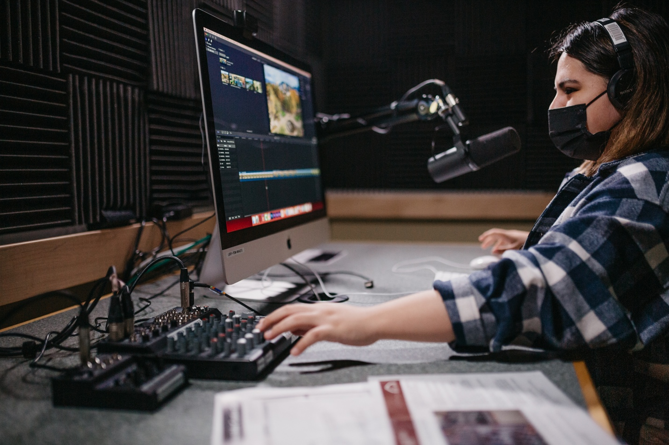

Articles: Inspire with Innovative Spaces and Services

- New DIY Media Lab
- Transforming user access to library resources with OpenAthens
- New online support portal
- Open Collections Delivery Service enhancement
- Partnering with UBC Campus Security on theft prevention
- Nass Reading Room reopens

New DIY Media Lab
The Chapman Learning Commons opens a full DIY Media Lab that allows anyone in the UBC community to create unique digital content. The sound-buffered studio, located in the Music Art and Architecture Library on Level 3 of the Irving K. Barber Learning Centre, enables library users to record high quality video and audio with access to microphones, a mixing board, a video camera, green screen, and a Mac computer with audio and video software. The studio is a result of a collaboration between UBC Library, UBC Studios, the Centre for Teaching, Learning and Technology and UBC IT.

Transforming user access to library resources with OpenAthens
The library introduces a new secure way for library users to access licensed online resources through OpenAthens, an identity-based authentication system that provides access using single sign-on (SSO) technology, both on and off-campus. Integrated with UBC’s campus-wide login (CWL), OpenAthens provides a more reliable and streamlined experience for library users, replacing EZproxy software and IP address-based authentication. The system also provides the library with more robust usage data, showing how often e-resource platforms are accessed in a designated period. Work to enrich this data begins in order to provide a more nuanced picture of UBC e-resource use, breaking down usage metrics by key user groups and faculties without compromising individual privacy.

Active OpenAthens accounts
96,200

68% – Students
15% – Alumni
11% – Faculty
6% – Staff

New online support portal
A new online support portal simplifies how library users find help via chat, email and phone. The Ask Us portal brings together several online service points for library support inquiries so that users can find subject librarians or search for additional resources, all in one place.

Open Collections Delivery Service enhancement
The library launches a significant update to its Open Collections website that enhances the findability and usability of items in the collections. Based on feedback and usage data, this update improves Google Scholar and public search engine indexing, while providing a new way for library users to use, re-use, and share Open Collections metadata through the Open Collection Research API.

Partnering with UBC Campus Security on theft prevention
The library partners with UBC Campus Security to launch a theft prevention pilot campaign to help students protect their valuables while using the library’s spaces. The campaign features messaging created in consultation with Chapman Learning Commons students to help provide students peace of mind when visiting branches and to foster good habits when using library study spaces.

Nass Reading Room reopens
The Nass Reading Room reopens following a much- anticipated space refresh. This quiet study space, located at the south end of Level 4 in the Irving K. Barber Learning Centre and equipped with new quiet study spaces and accessible group tables, is a popular destination for students looking for a spot to work with great views and limited noise.

Section 5
Steward the organization

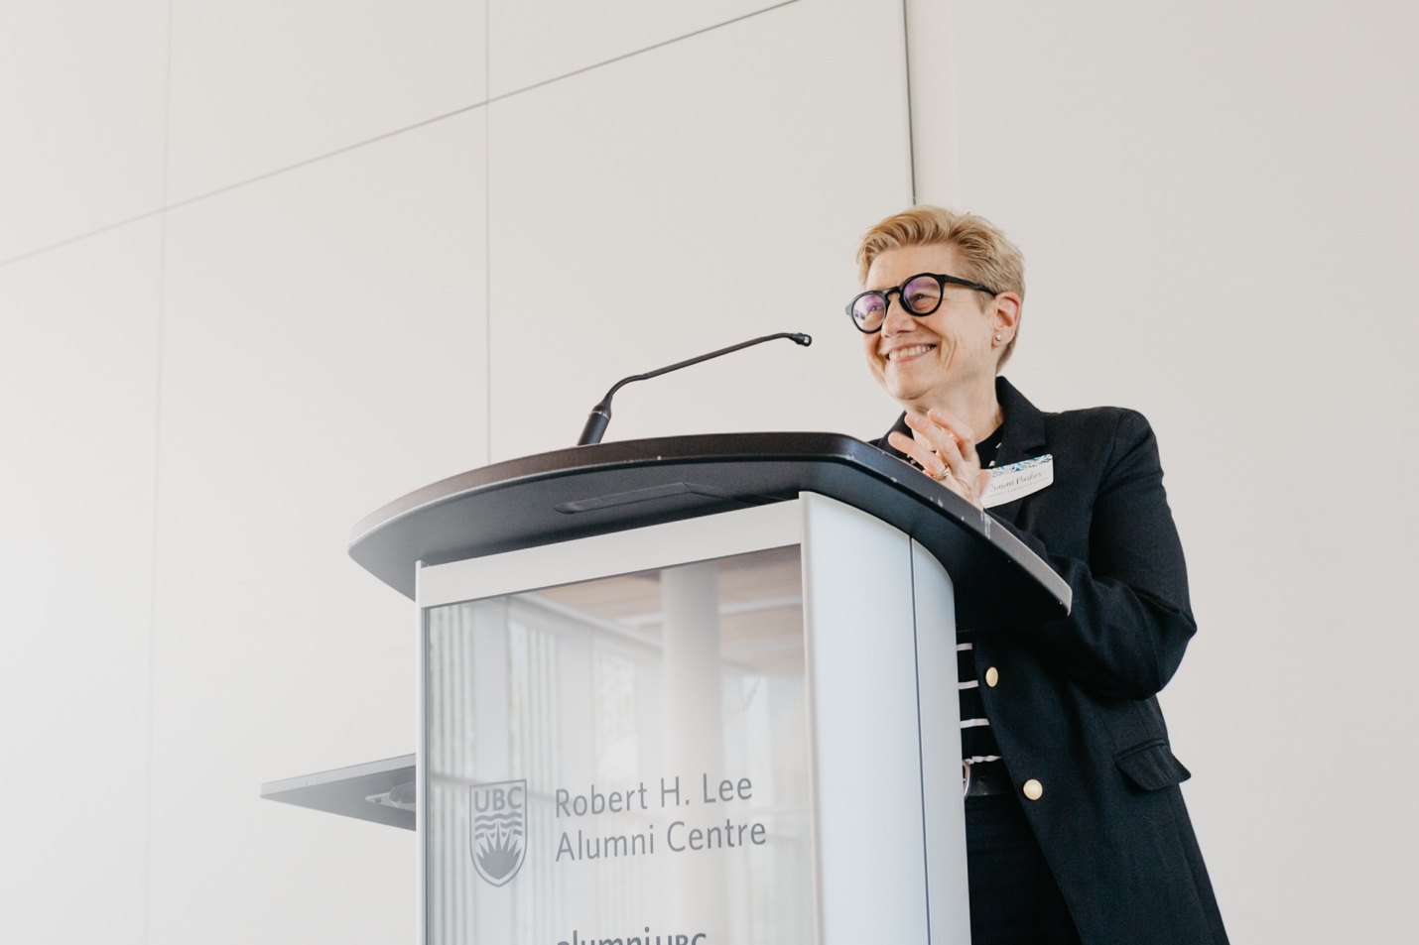

Articles: Steward the organization

- Dr. Susan E. Parker elected vice-president/ president-elect of ARL
- Irving K. Barber Learning Centre Librarian awarded VAHMS Recognition Award
- Centre for Writing and Scholarly Communication launches writing podcast
- Xwi7xwa Librarian chosen as one of ALA’s Emerging Leaders

Dr. Susan E. Parker elected vice-president/ president-elect of ARL
Dr. Susan E. Parker is elected vice-president of ARL for a one-year term. The Board of Directors is the governing body of the association and represents the interests of ARL member libraries in directing the business of the association. This includes establishing operating policies, budgets, fiscal oversight, modifying the ARL mission and objectives and representing the association to the community.

Irving K. Barber Learning Centre Librarian awarded VAHMS Recognition Award
Allan Cho, Community Engagement Librarian at the Irving K. Barber Learning Centre, is awarded the Vancouver Asian Heritage Month Society (VAHMS) Recognition Award. Every year, VAHMS honours three individuals, community organizations, or educational institutions representing Pan-Asian communities that have made significant contributions to VAHMS’ vision of fostering, promoting and celebrating the arts and cultural diversity that Asian Canadian communities bring to Canadian society.

Centre for Writing and Scholarly Communication launches writing podcast
The Centre for Writing and Scholarly Communication launches the first season of “Interrobang: A Writing Podcast‽”. Featured guests include UBC faculty members Dr. Heidi Tworek, Dr. Gregory Mackie and Dr. Evan Thompson. Production of the podcast is made possible through an innovation grant from UBC Library.

Xwi7xwa Librarian chosen as one of ALA’s Emerging Leaders
Kayla Lar-Son, Indigenous Programs & Services Librarian at Xwi7xwa Library, is chosen as one of ALA’s Emerging Leaders for the 2022 cohort. The program is designed to enable library staff and information workers to participate in project planning work groups, network with peers, gain an inside look into ALA structure, and have an opportunity to serve the profession in a leadership capacity early in their careers.

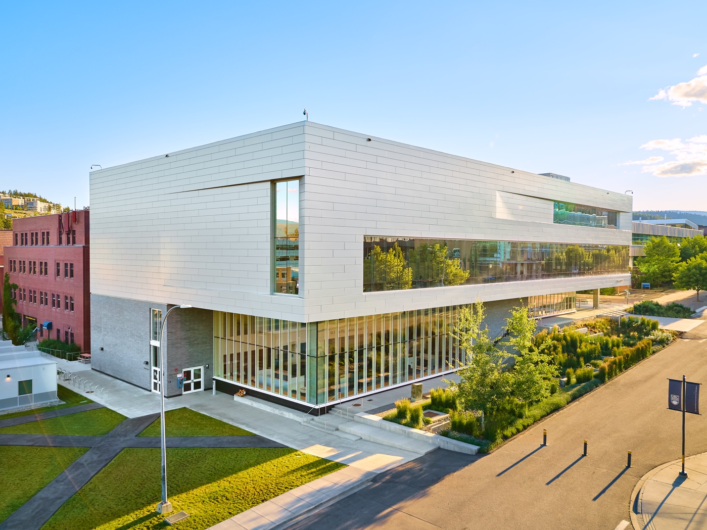

UBC Okanagan Library Highlights

The COVID-19 pandemic brought with it a rapid pivot to online service models for all areas of the Library, including popular Student Learning Hub, Centre for Scholarly Communication, and teaching and learning supports, while staff continued to provide contactless access to print collections. Highlights of this unique period included significant growth in Academic Integrity Matters referrals, the Library’s coordination of the Okanagan Campus’ Open Educational Resource Grant program, a new non-credit credential in Scholarly Research, Writing, and Publishing in collaboration with the College of Graduate Studies, the expansion of the British Columbia Regional Digitized History project, a makerspace-led initiative to create much-needed PPE for our community, and a series of engaging online events celebrating diversity, inclusion, and Indigeneity.

Find out more in the:
2020-2021 Report to UBC Okanagan Senate.

Acknowledgements

I would like to thank the many contributors to this report and those who contributed to its development and production.

-Dr. Susan E. Parker
University Librarian

Produced by:
Library Communications and Marketing University
of British Columbia Library Irving K. Barber Learning Centre
1961 East Mall, Vancouver, British Columbia Canada V6T 1Z1

Design and Production
Phoebe Chan,
Library Communications and Marketing
August 2022

Photography Credits

Pages
1,3,5,9,12,17,20: Library Communications and Marketing
22: Exterior view of the Commons at UBC Okanagan
(Hover Collective / UBCO University Relations)

